**CENTRE FOR GANDHIAN STUDIES**

|  |  |
| --- | --- |
| **VISION**  **&**  **MISSION** | Toimpart the great teachings of Mahatma Gandhi and to encourage Ahimsa, Spirit of Patriotism, Discipline, Dignity, Intelligence and Religious Tolerance among the students community and the general public. |
| To put in to Mahatma Gandhi Educational ideas of imparting life-building, man making and character building skills through Education, Research and Extension. |

|  |  |  |
| --- | --- | --- |
| **Name** | **Designation & Dept./Division/College.** | **Status** |
| Dr.A.Balu | Principal i/c  College of Education | Director |
| Dr.K.Ganesamurthy | Assistant Professor  Department of Corporate secretaryship | Member |
| Dr.T.Sathiamoorthy | Assistant Professor  Department Of Botany | Member |
| Mrs.T.Maheswari | II M.Ed. | Member |
| Mr.R.Karthick | II B.Ed. | Member |

|  |  |
| --- | --- |
| **Range of**  **Activities**  **(Suggested)** | National Conferences |
| Student studies on rural consumer behavior, their awareness level of consumer Rights, etc. |
| Programs for public/retailers/business |

**Activities Carried out**

|  |  |  |  |
| --- | --- | --- | --- |
| **Year** | **Description of Activity** | **Date** | **Participants/Beneficiaries** |
| 2012 | ,e;jpatpLjiyNth;fis ,isNahh; mwpjy; - fUj;juq;F | 22.03.2012 | B.Ed. khzth;fs; |
| 2014 | GANDHI JAYANTHI CELEBRATION | 02.10.2014 | B.Ed. students |
| 2015 | TEACHERS DAY CELEBRATION | 08.09.2015 | B.Ed. students |
| 2015 | GANDHI JAYANTHI & INTERNATIONAL NON-VIOLENCE DAY | 02.10.2015 | B.Ed. students |
| 2015 | ONE DAY VALUE EDUCATION AND SUPW CAMP | 26.11.2015 | B.Ed. students |
| 2016 | GANDHIAN STUDIES SUPW CAMP | 27.07.2016 | B.Ed. students |
| 2016 | GANDHI JAYANTHI & INTERNATIONAL NON-VIOLENCE DAY | 02.10.2016 | B.Ed. students |

**Any other**

**Alagappa University College of Education**

**Karaikudi- 630 003.**

**Gandhian Studies SUPW Camp**

Date : 27.07.2016

On 27th July 2016, SUPW camp is held in our Alagappa University College of Education seminar hall at 3.00 p.m.Dr.A.Balu, Principal (i/c), AUCE delivered the presidential address.Mrs.S.Indra delivered special address on this function. All the staff members, B.Ed., students teachers are participated.

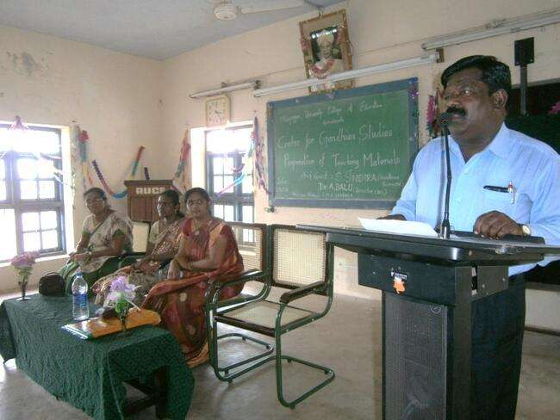

Dr.A.Balu, Principal (i/c), Mrs.S.Indra, Chief Guest, Mrs.A.RubeJesintha, Mrs.EMN.Sharmila

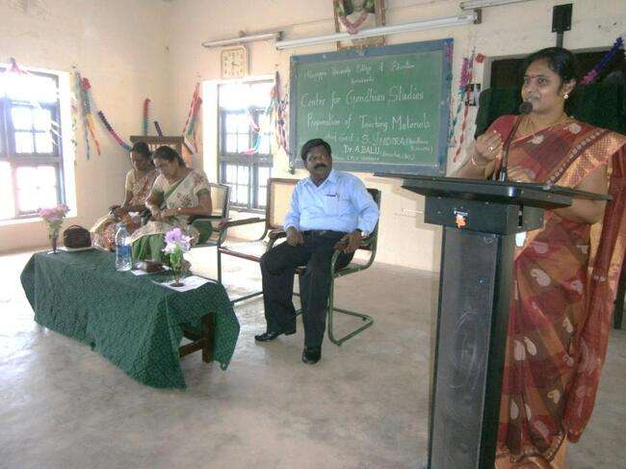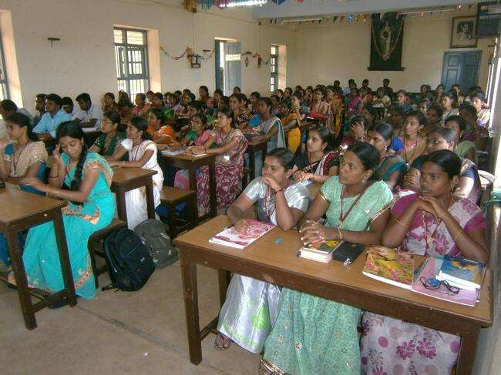

Mrs.S.Indra

M.Ed., & B.Ed., Students



