CENTRE FOR YOGA EDUCATION
ALAGAPPA UNIVERSITY, KARAIKUDI.

Aim and Purpose  (Suggested) | AIM  1) To enable the students to have Good Health.  2) To practice mental hygiene.  3) To possess Emotional stability.  4) To integrate Moral values.  5) To attain higher level of consciousness  6) To enable the students to become competent and committed professionals as yoga trainer.
PURPOSE
The original context of yoga is spiritual development practices to train the body and mind to self observe and become aware of their own nature. The purpose of yoga is to cultivate discernment, awareness, self-regulation and higher consciousness in the individual. As the split occurring between those seeking physical developments versus those seeking spiritual development has widened, the lack of awareness and attention to inner experience has disconnected the practitioner from his body.

Name | Designation & Dept./Division/College. | Status
Faculty | Dr.S.Saroja,  Assistant Professor,  Alagappa University College of Physical Education, Karaikudi. | Coordinator
Faculty | (From Coordinator’s Faculty or other faculty) | Member
Faculty | (From Other Faculty)  - Dr.RM. Vidhyavathi,  Assistant Professor,  Department of bio-informatics.  - Dr. U. Arumugam ,  Assistant Professor,  Corporate Secretaryship.  - Dr.M.Sivakumar,  Assistant Professor,  Department of Physics, | Member
Faculty | (From another Faculties) | Member
Student Representative | (From Coordinator’s Dept.) | Member
Student Representative | (From other Faculties) | Member

Range of Activities
(Suggested)
To conduct orientation programme for Affiliated college physical Education teachers. All India Yoga Competition (Syllabus, Rules & Regulations)
To conduct Yoga awareness programme for university students(Practical)
To conduct Inter collegiate yoga competition on 19th January 2017
To conduct summer yoga camp for school , college students and public
To conduct Awareness program for affiliated college students( International Yoga Day Syllabus)
Activities Carried out
Year | Description of Activity | Date | Participants/  Beneficiaries
2016 | Yoga Awareness programme- yoga for Human Excellence | 16.03.2016 | University teaching staff
 |  | 17.03.2016 | University Administrative staff
2016 | International Day of Yoga | 21.6.2016 | school students(1000 students)
2016 | Annual summer Yoga coaching camp | 27th April to 12th may 2016 | School, college students and public.
2017 | Workshop and Activity based Yoga(WAY-2017) | 8th February 2017 | University Departments & Affiliated college students
2017 | Inter collegiate Yoga Competition | 24th February | University Departments & Affiliated college students
ACADEMIC
2016 | Certificate course in Yoga- Distance Education | --------- | University students and public

Any other
Alagappa University
Centre for yoga education
Organized
Workshop and activity based yoga (way-2017)
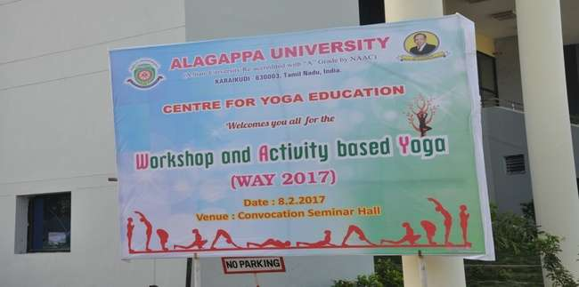
Flux for WAY-2017
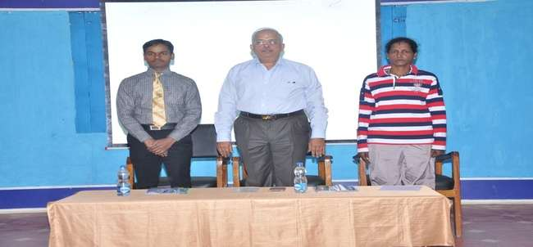
Inaugural function on the Dias (from the left to right) Dr.P.Baskaran Dronacharya Awardee, Prof.V.Balachandran Registrar, Dr,S.Saroja
Co-Ordinator for Yoga.

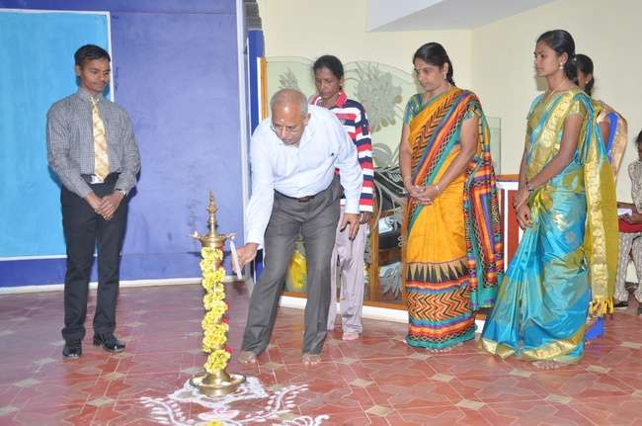
Lighting the KuthuVilaku
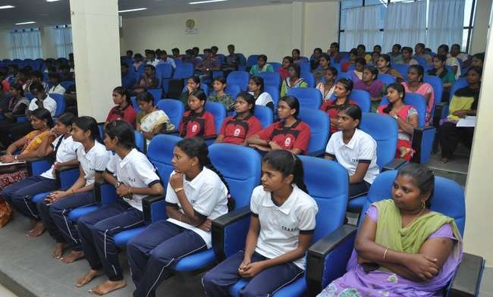
Participants from Affiliated Colleges and University Department Students

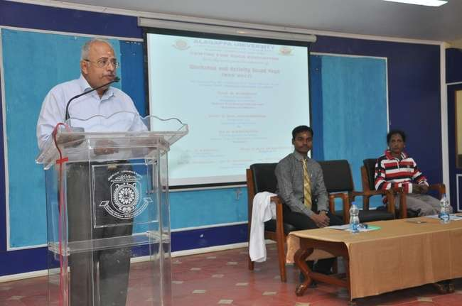
Presidential Address given by Prof.V.Balachandran, Registrar
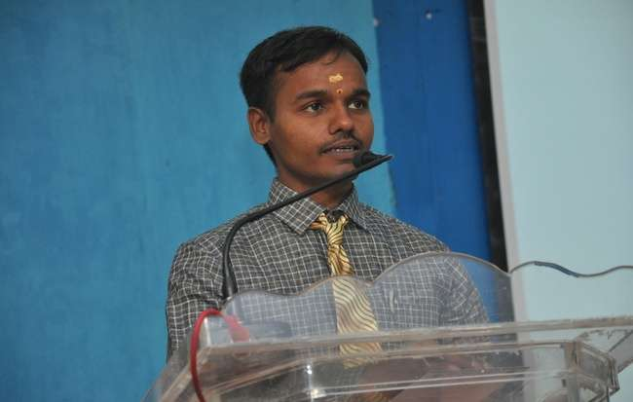
Special Address given by Dr.P.Baskaran, Dronacharya Awardee

YOGA DEMONSTRATION BY DR.P.BASKARAN
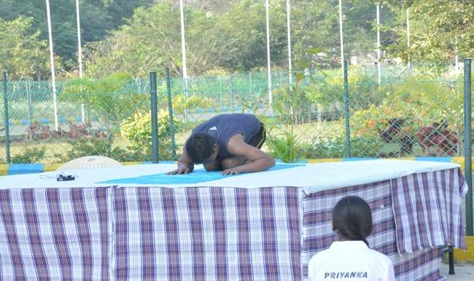
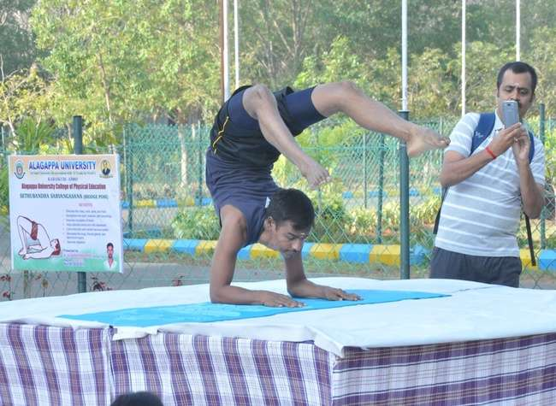

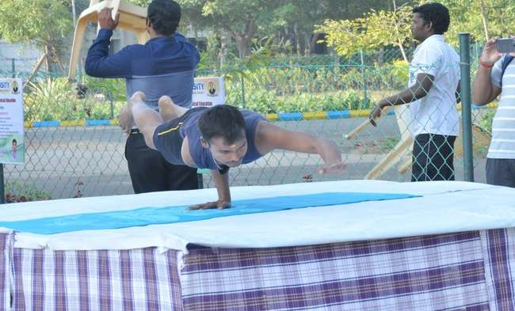
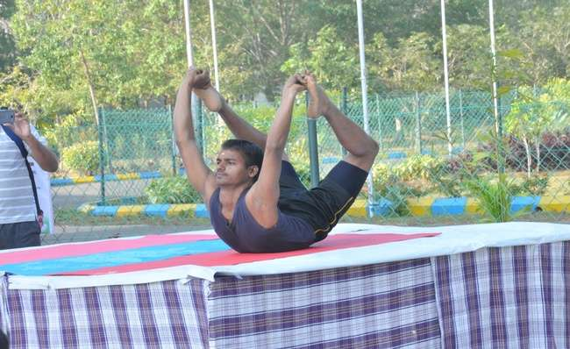

STUDENTS DEMONSTRATION
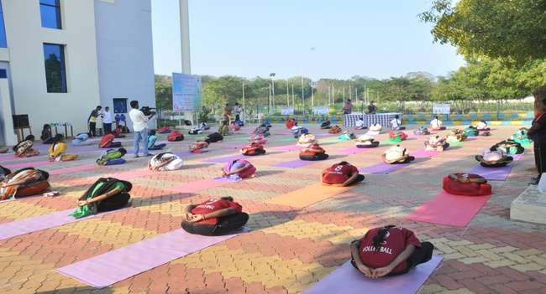
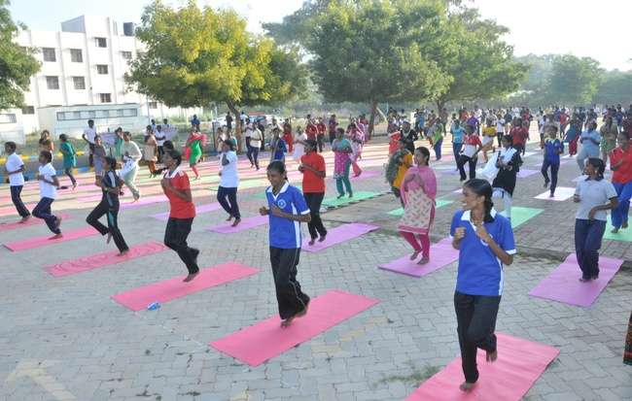

VALEDICTORY FUNCTION
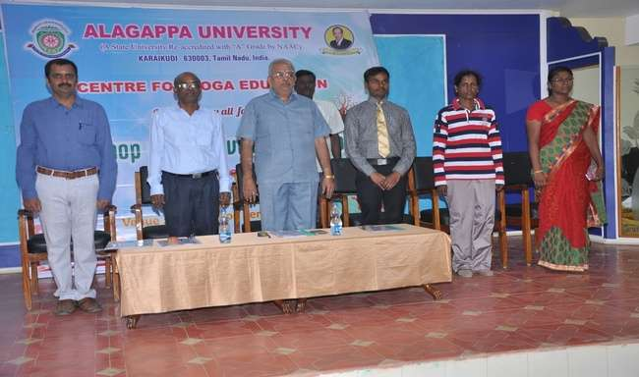
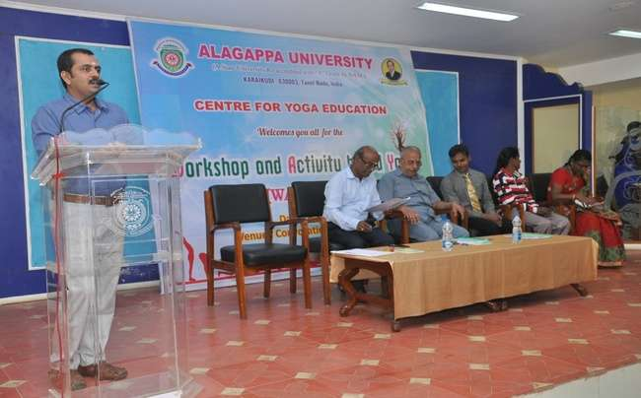

FEEDBACK

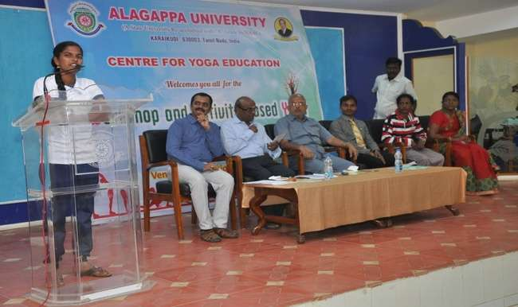
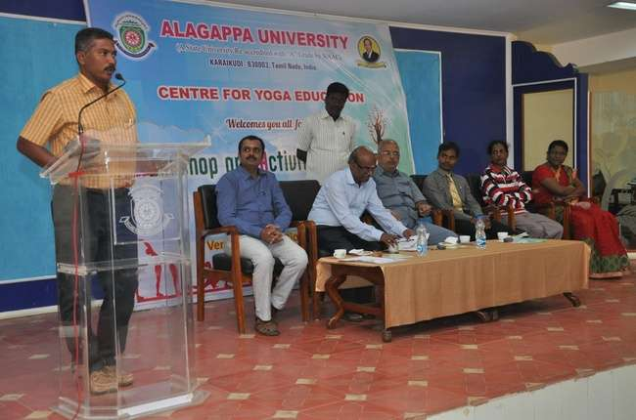

CERTIFICATE DISTRIBUTION
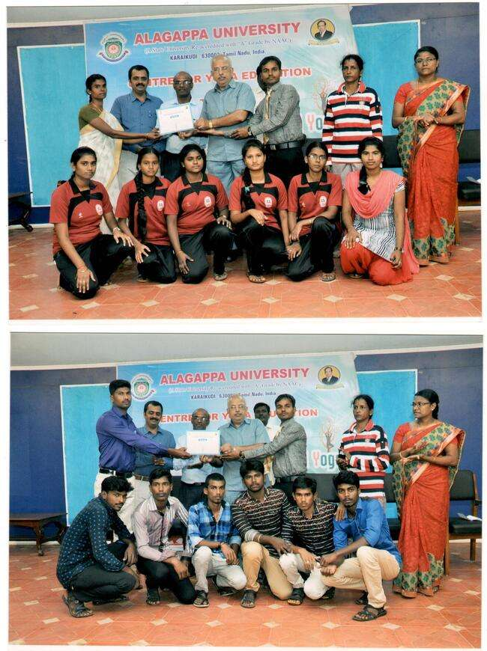

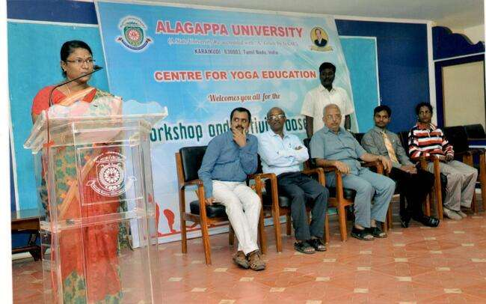
Vote of thanks

