Coaching Scheme for Entry into Services

Aim and Purpose  (Suggested) | To prepare students to face the challenges of entry into various kinds of services
 | To develop life and soft skill competencies to the students for their lifelong employability by the way of providing special coaching especially to SC/ST/OBC and Minorities.
 | To motivate and encourage students to participate and succeed in various entrance and competitive examinations

Name | Designation & Dept./Division/College. | Status
Dr G Parimalarani | Associate Professor, Department of Bank Management, Alagappa University | Coordinator
Dr. G. Sankaranarayanan | Professor, Department of Physics, Alagappa University | Member
Dr V Sivakumar | Associate Professor, Department of Logistics Management | Member
Dr T Thiruveni | Assistant Professor, Directorate of Distance Education | Member
Student Representative | Ms. A Lamiya, II MBA (Banking & Insurance) | Member
Student Representative | Mr. V. Govindan, Ph D Scholar, Department of Physics | Member

Range of Activities  (Suggested) | Conducting Model Entrance Examinations
 | Organizing Aptitude Test Skills Training Workshops
 | Conducting Communication Skills and Reasoning Skills Training Programs

Activities Carried out
Year | Description of Activity | Date | Participants/  Beneficiaries
2017 | One Week Workshop on Career Guidance | March 8 to March 13, 2017 | 400 students of Final Year PG students
2015 | Coaching Scheme Classes on Problem Solving, Communication and Personality Development | January to April 2015 for 20 weeks | 409 students from University Departments & Affiliated Colleges
2015 | Entrance Examination for Coaching Scheme Participation | January 8 and January 9, 2015 | 1380 students from University Departments and Affiliated Colleges

Photo Gallery
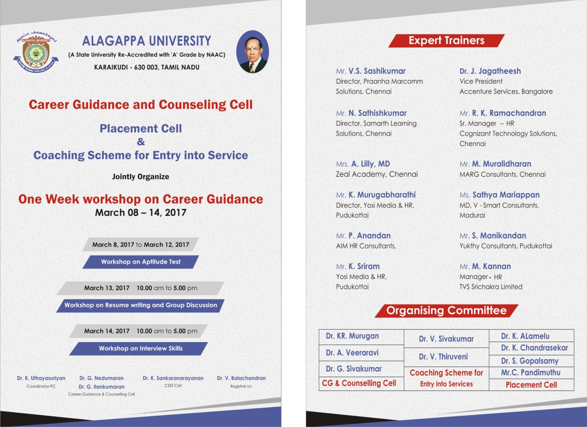

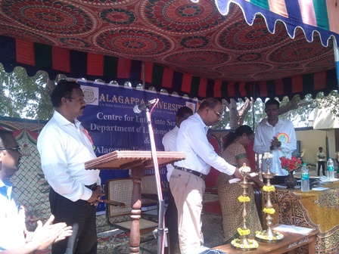

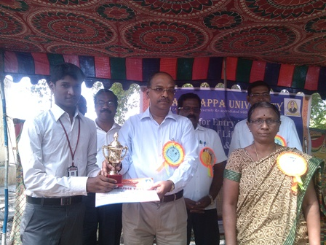

“Aptitude Skills Training Program” on 8th - 10th March, 2017

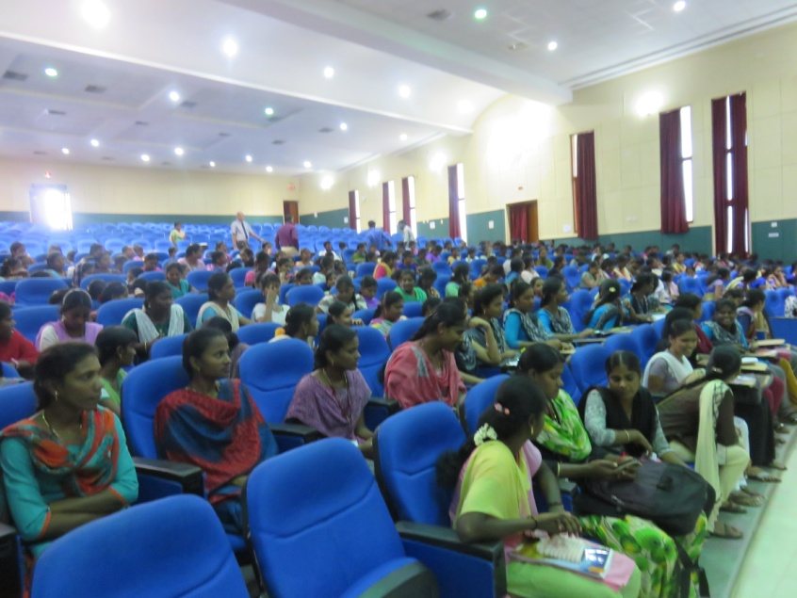

A photographic view on the participants in the Convocation Hall

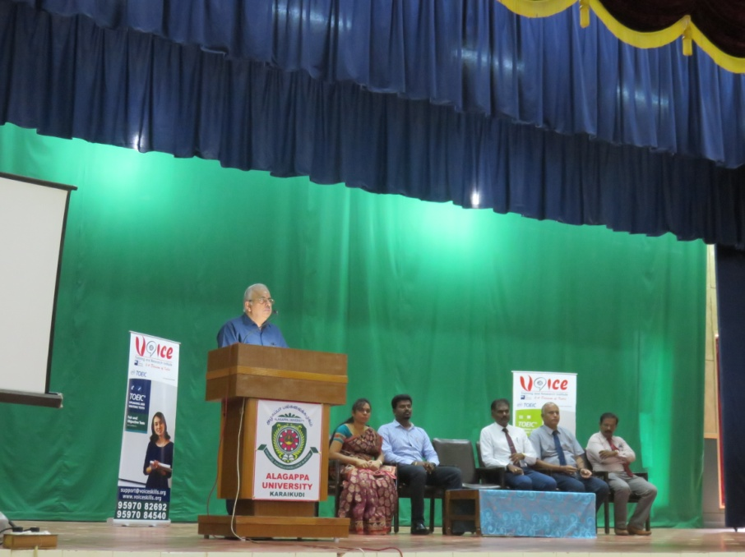

Inaugural address by Prof.V.Balachandran, Registrar i/c, Alagappa University

