SC/ST CELL

Aim and Purpose  (Suggested) | To guide the SC/ST Students of the University and affiliated college of Alagappa University to optimally utilise the benefits of the schemes offered by the State Government, Government of India and UGC.
 | To help the SC/ST categories to integrate with the mainstream of the university community and to remove difficulties.
 | To conduct the remedial coaching classes.

Name | Designation & Dept./Division/College. | Status
Dr. G. Nedumaran | Associate Professor, Department of Commerce, Alagappa University. | Coordinator
Dr. M. Pandi | Professor & Head, Department of Tamil | Member
Dr. V. Palanisamy | Professor & Head, Department of Computer Application, Alagappa University. | Member
Dr. S. Ganapathy | Professor, Department of Commerce, Alagappa University | Member

Range of Activities  (Suggested) | To celebrate “Constitution Day”
 | It lays down the framework defining fundamental political principles, establishes the structure, procedures, powers and duties of government institutions and sets out fundamental rights, directive principles and the duties of citizens.
 | Programs for Students/Staffs/Public

Activities Carried out
Year | Description of Activity | Date | Participants/  Beneficiaries | Venue
2015 | The Cell organised the first function is “Constitution day” Celebration on 26.11.2015, in the Eva of Dr. B. R. Ambedkar 125th Birth day Celebration in India.  The Constitution day is jointly organised by SC/ST Cell and University NSS. Our Vice Chancellor Dr. Prof. S. Subbiah entering the Auditorium to attend the constitution day celebration.  The SC/ST Cell Coordinator Dr. S. Ganapathy to deliver welcome address at the function.  Our Vice Chancellor to honouring the Guest with the Shawl to our Senate Member and Guest Speaker.  Our SC/ST Cell Co-ordinator to honouring the Vice Chancellor with the Shawl.  The NSS Co-ordinator Mr. S. Rajaram reading Constitution day pledge followed by all on the stage and off the stage.  Our Vice Chancellor delivers Presidential address at the function.  The Senate Member Dr. V. Sethuramalingam delivers key note address at the function and the Guest Speaker Prof. M. Tamilmaran delivers special address at the function.  Finally delivers vote of thank by our NSS Co-ordinator at the function. | 26.11.2015 | Presidential address:  Dr. S. Subbiah  Vice-Chancellor, Alagappa University.  Key note address:  Dr. V. Sethuramalingam  Member of Senate, Alagappa University.  Guest Speaker:  Prof. M. Tamilmaran  Professor, Department of Tamil  Periyar University, Salem. | Convocation Seminar Hall, Alagappa University.
2016 | The Cell organised the second function is “Constitution day” Celebration on 26.11.2015, in the Eva of Dr. B. R. Ambedkar 126th Birth day Celebration.  The NSS Co-ordinator Mr. S. Rajaram reading Constitution day pledge followed by all on the stage and off the stage.  The SC/ST Cell Coordinator Dr. G. Nedumaran to deliver welcome address at the function.  The Prof. V. Balachandran, Registrar to delivers valedictory address.  Mr. A. Ilankumar Sampath, Advocate to delivers special address at the function.  Finally delivers vote of thank by our NSS Co-ordinator at the function. | 26.11.2016 | Presidential address:  Dr. S. Subbiah  Vice-Chancellor, Alagappa University.  Felicitation address:  Dr. V. Balachandran  Registrar, Alagappa University.  Special Address:  Mr. A. Ilankumar Sampath  Advocate, Tiruchirappalli. | Convocation Seminar Hall, Alagappa University.

The Cell organised the first function is Constitution day Celebration on 26.11.2015, in the Eva of Dr. B. R. Ambedkar 125th Birth day Celebration in India.

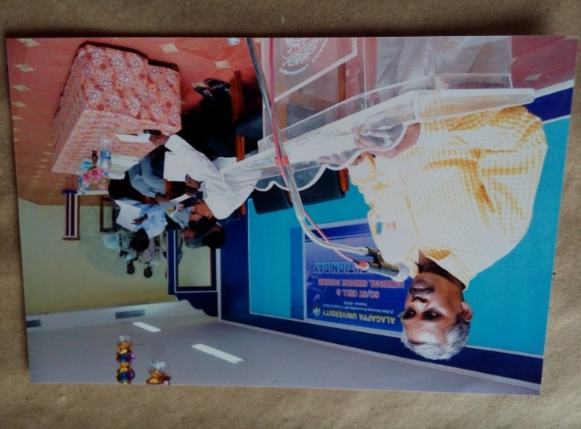
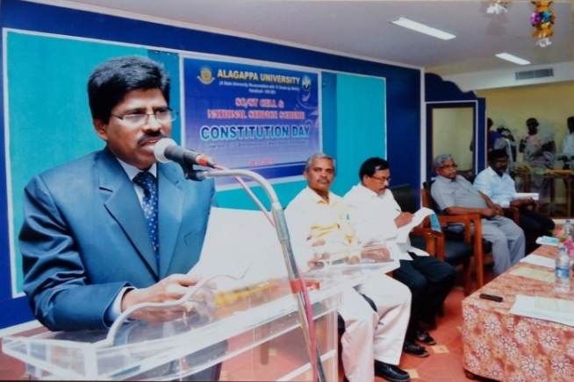
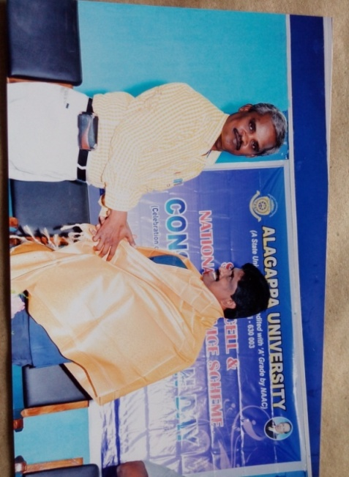
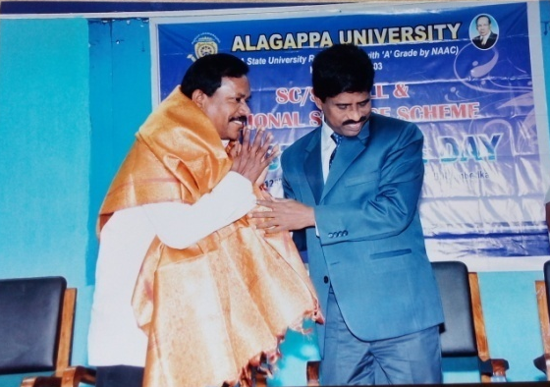
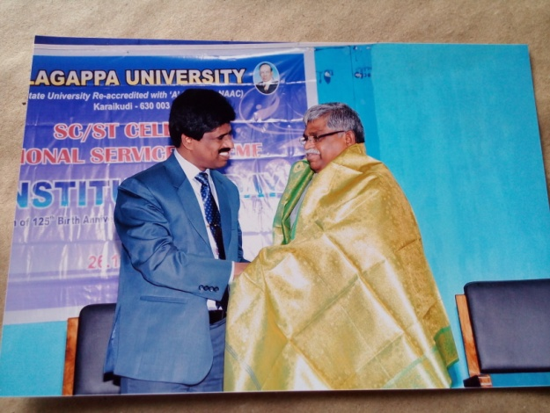

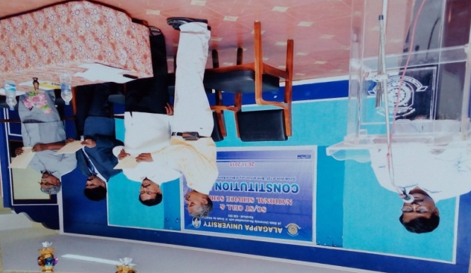

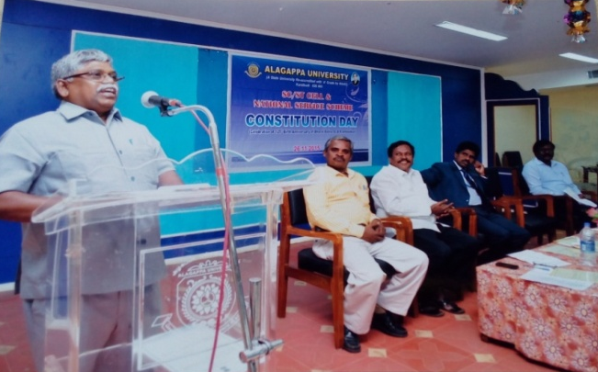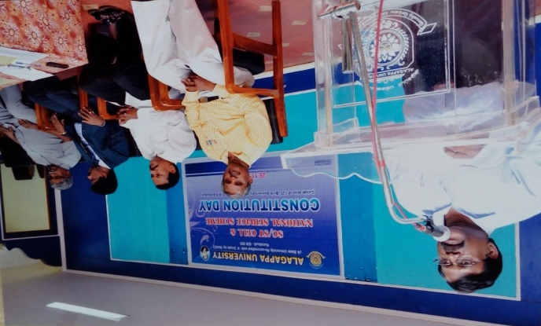
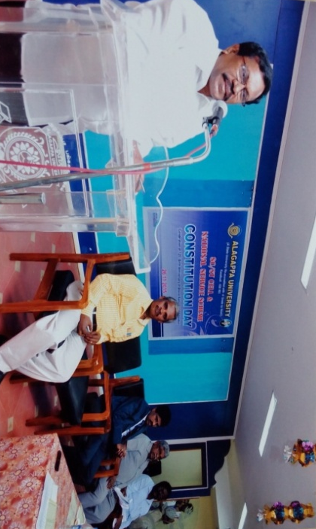

The Cell organised the first function is Constitution day Celebration on 26.11.2016, in the Eva of Dr. B. R. Ambedkar 126th Birth day Celebration in India.

