REMEDIAL COACHING FOR SC/ST/OBC (NON CREAMY LAYER) MINORITY COMMUNITY
Aim and Purpose | To improving academic skills and linguistic proficiency of the students in various subjects
 | To raising their level of comprehension of basic subject to provide a stronger foundation for further academic work
 | To Strengthening their knowledge, skills and attitudes in such subjects, where quantitative and qualitative techniques and laboratory activities are involved so that proper guidance and training provided under the programme may enable the students to come up to the level necessary for pursuing higher studies efficiently.

Name | Designation and Dept./Division/College | Status
Dr. S. Ganapathy | Professor, Dept. of Commerce | Coordinator
Dr. S. Nagarajan | Associate Professor, College of Physical Education | Dy.Coordinator

Range of Activities (Suggested) | Classes were handled other than the regular working hours/days
 | The students of the affiliated colleges and the students of the university departments were beneficiaries.
 | Programmes were conducted by the team of experts
 | Copies of the study materials were given to all the participants at free of cost
 | By using this fund, English language laboratory was established to improve the communication skill of the students.
 | Subject books, competitive exam books, NET coaching books etc are available in the general library. This expenditure is met out of this fund.

Activities Carried out
Year | Description of Activity | Date | Participants / Beneficiaries
2013-14 | Rs. 1,66,374 Spent to organize Special Coaching Programme | Even Semester | 166
2014-15 | --- | --- | ---
2015-16 | Rs. 1,66,000 Spent to the Department as per the Strength of the students | Even Semester | 1164
2016-17 | The work is under Progress | --- | ----

Activities 2016-2017
Department of Logistics Management
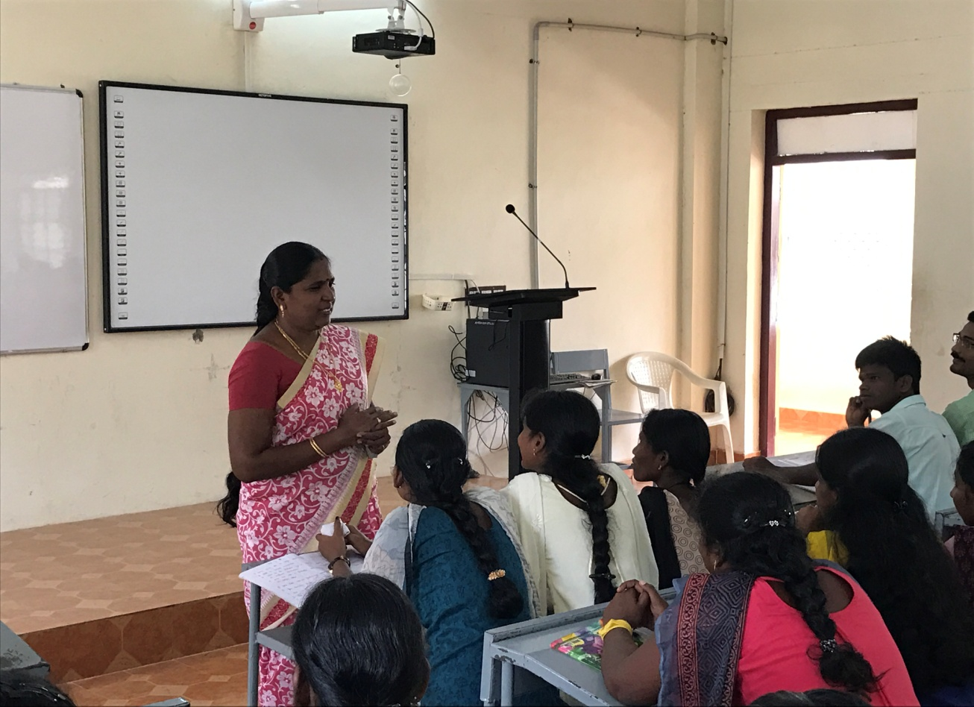
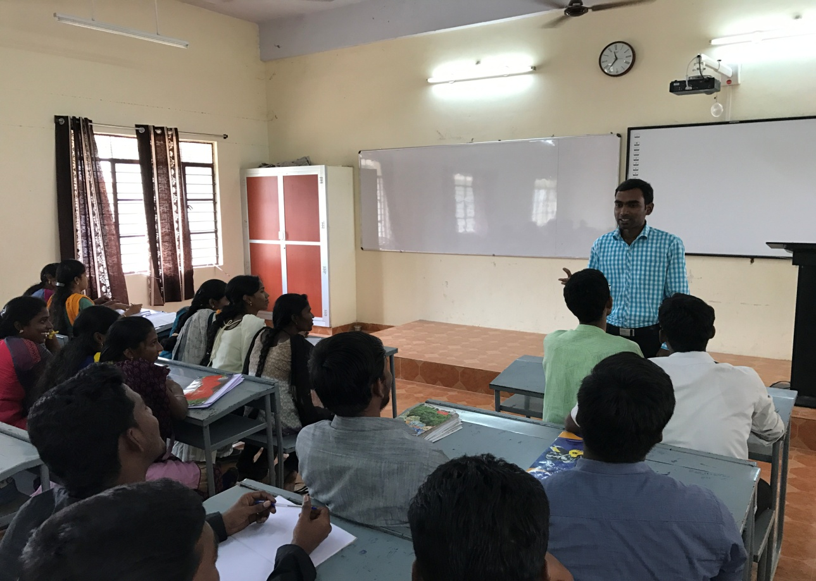
Remedial Coaching classes for 1st year MBA - LM

Remedial Coaching

classes for 2nd year MBA – LM

Remedial coaching classes for MBA – LM 2nd Year

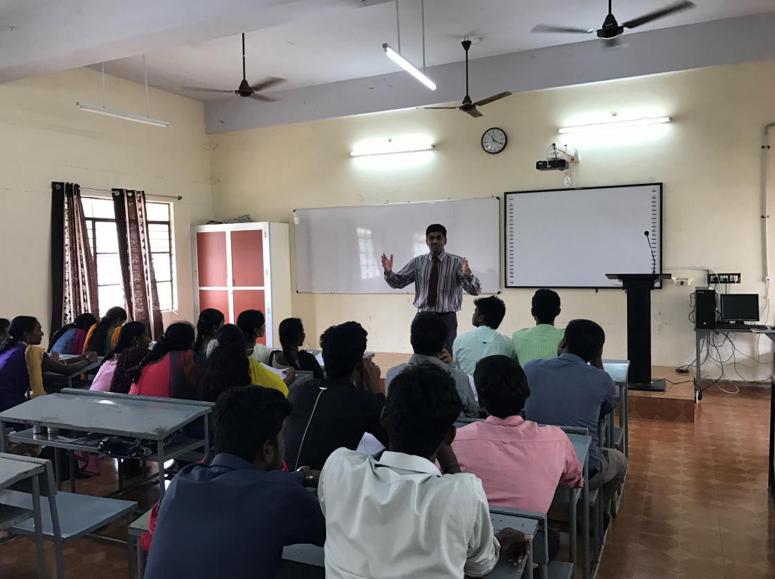

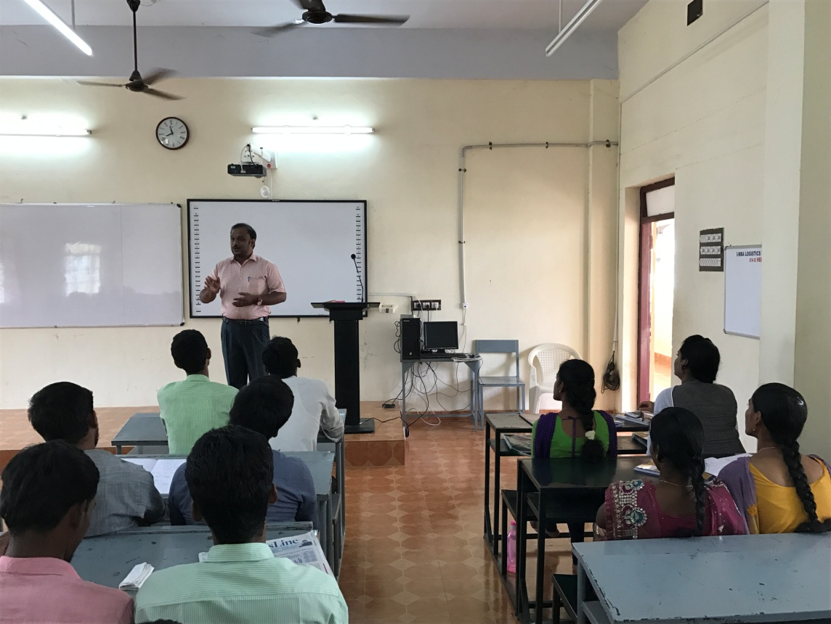

Department of Corporate Secretaryship
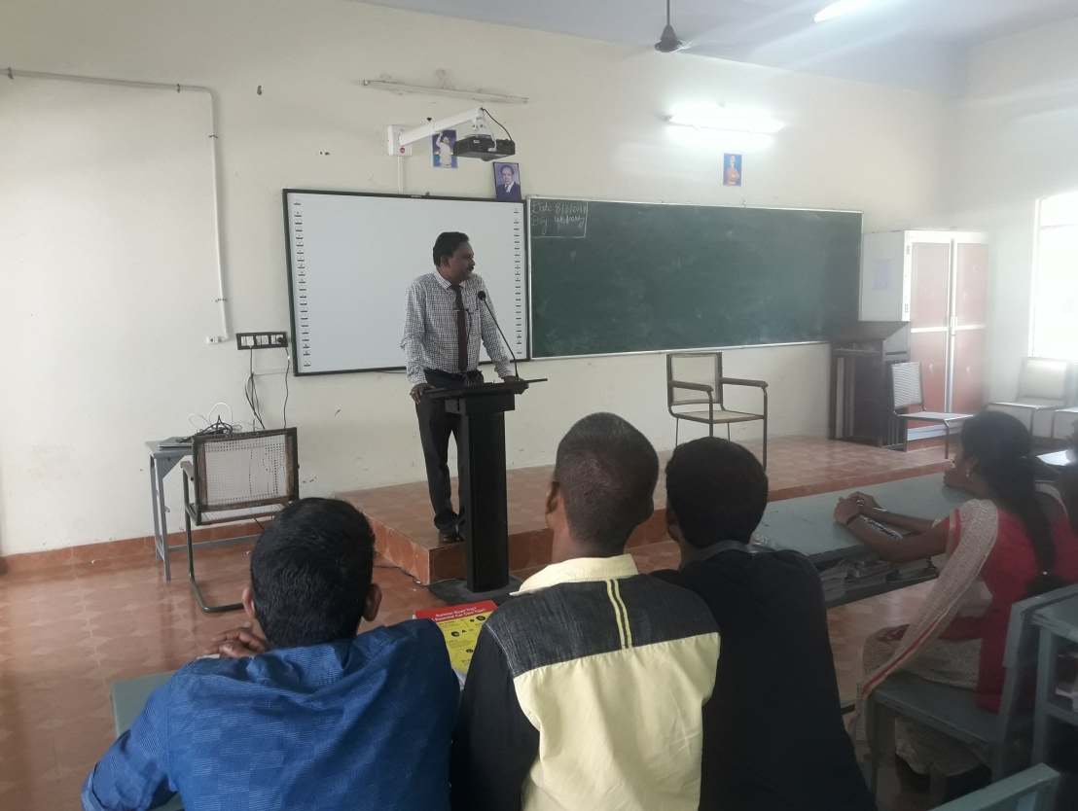
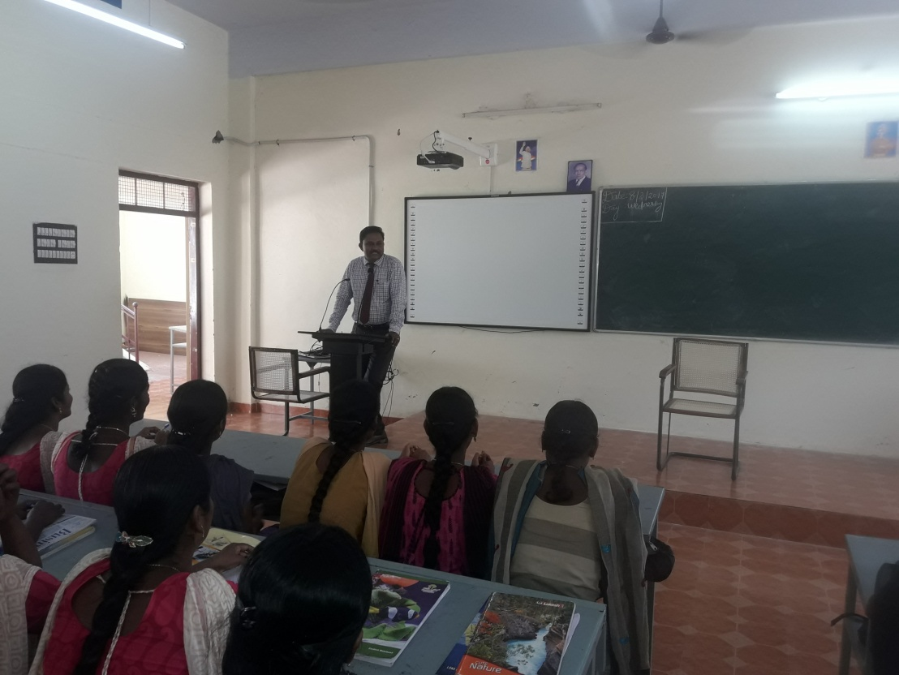
Remedial Coaching class for MBA – CS 1st year

Remedial Coaching class for MBA – CS 1st year
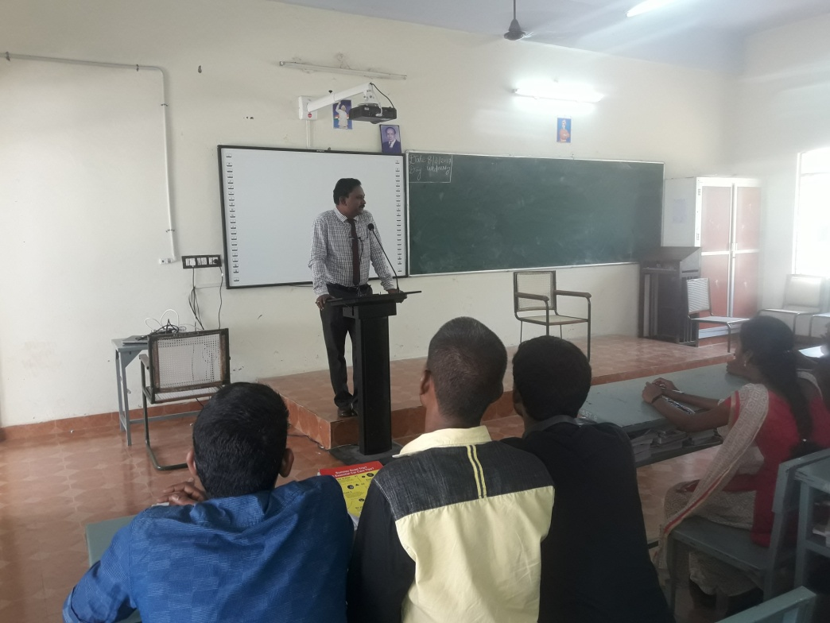

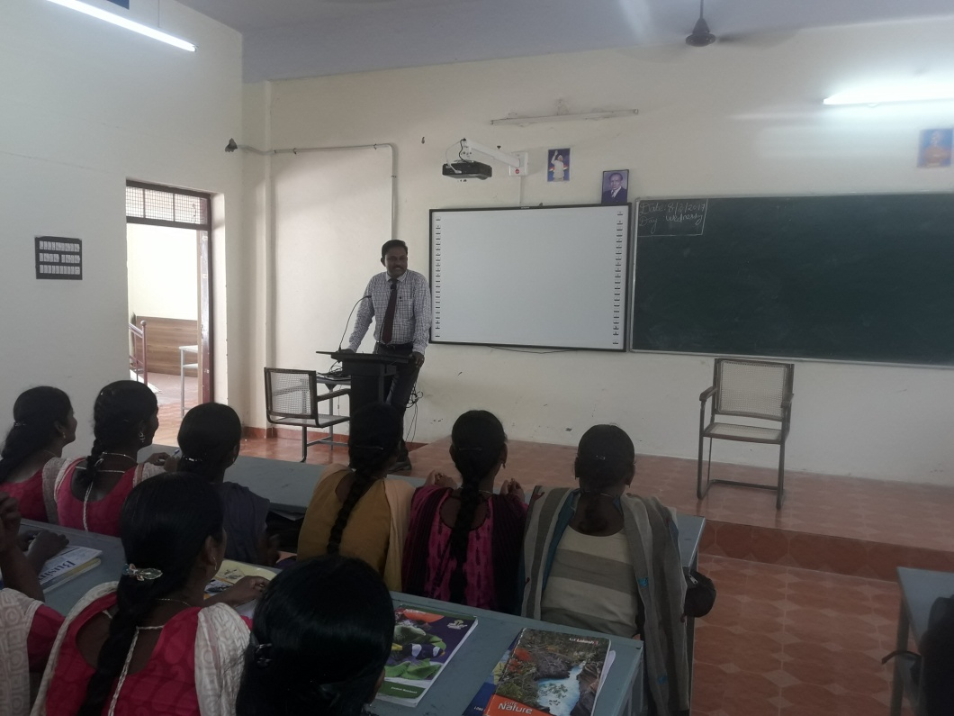

Department of Commerce
Remedial Coaching class for M.Com

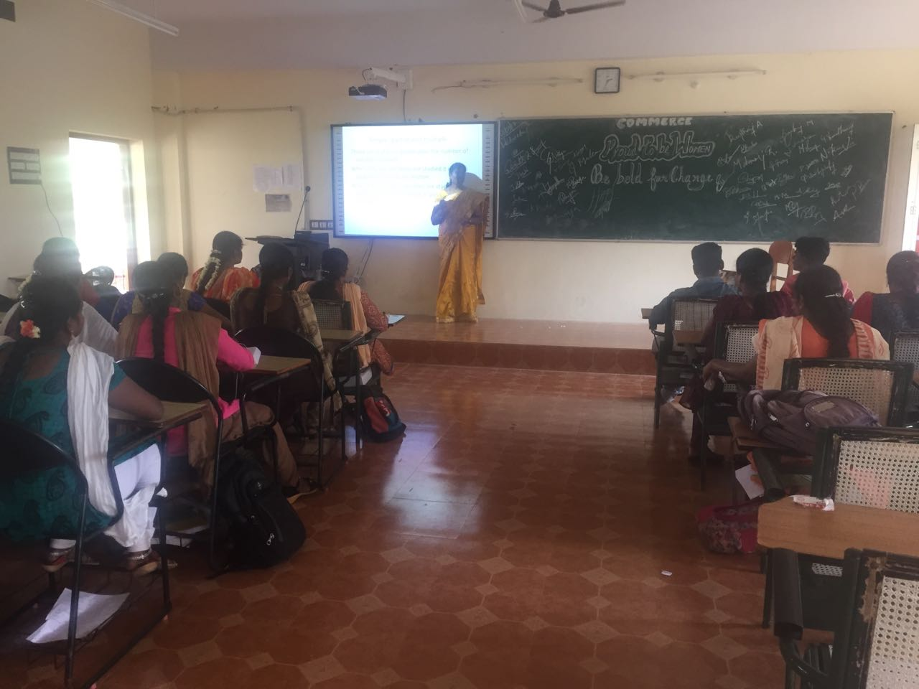

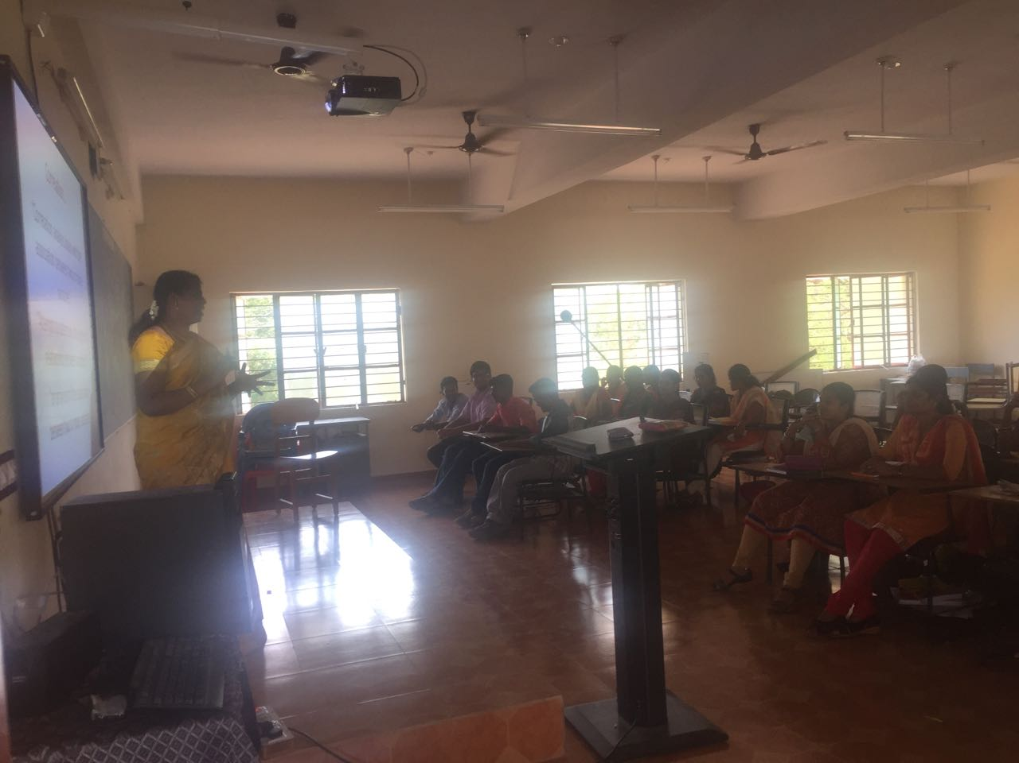

Department of International Business
Remedial Coaching class for MBA – IB

