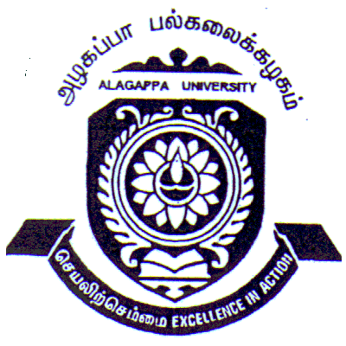
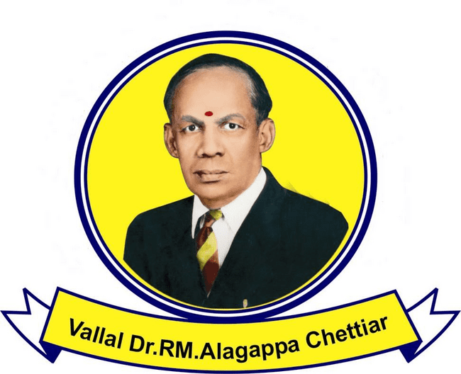
ALAGAPPA UNIVERSITY, KARAIKUDI-630 003.
(A State University Reaccredited with ‘A’ Grade by NAAC)

DEPARTMENT OF TAMIL

THIRUKKURAL RESEARCH CENTRE

Aim and Purpose  (Suggested) | The Centre continues to organize national and international conferences on Thirukkural by focusing on the pivotal themes and forms related to life styles; and to publish the research articles in the form of edited volumes.  The Centre precisely is established to accumulate and cater the necessary documents and all other resources related to Thirukkural.
The Centre primarily aims at extending its services for the research scholars, learners and to the mass at larger level.
The core objective of this Centre is to promote and to elevate the culture, tradition, management, agriculture, professions, family, individuality, social values and ethics of Tamil origin and the historicity, thematic and formalistic convergence of Tamil literature throughout the world.

 | To conduct Essay and Elocution Competitions to the School and College Students on Thaimozhi.

Name | Designation & Dept./Division/College. | Status
Faculty | Prof.Dr.M.Pandi | Director  Thirukkural Research Chair
Faculty | Dr.M.Selvam  Dr.T.R. Gurumoorthy  Dr.V.Balachandran | Member

Range of Activities  (Suggested) | Three Days International Seminar 7-9.01.2016
 | A Research Chair on Thirukkural will also be instituted through the Centre to facilitate the research and to provide adequate knowledge on Thirukkural in its ways and means. The Centre will conduct seminars, workshop and conferences. Translate the Thirukkural in various languages.
 | Programme for Students
Activities Carried out
Year | Description of Activity | Date | Participants/  Beneficiaries
2016 | Three Days International Seminar | 7-9.01.2016 | Prof.S.Subbiah,  Vice Chancellor,  Alagappa University,  Karaikudi.  Thiru.Kundrakudi Ponnambala Adigalar  Kundrakudi  Thiru.AN.Lakshmanan Chettiar,  President, Sree Sevugan Annamalai College,  Dr.Subhasini Tremmel, Germany.  Tamil Saviour Prof.Aagan Babu,  Australia.  Prof.K.Sivagurunatha Pillai,London  Prof.S.Sachchithanandam, France  Prof.Ulrik Nicholas, Germany,  Mr.S.V.Lingam, Malaysia.  Prof.Alexander M.Dubiyanski Russia  Dr.Vasek, France  Dr.R.Vimalan, Singapore  Thiru.V.R. Manickam, Singapore.

Photos

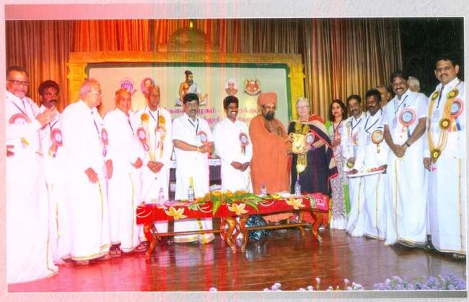

International Seminar – Thirukkural

