WOMEN HARASSMENT PREVENTION CELL

AIM | To create awareness about women Harassment Prevention among the students, teaching & non – teaching community.
 | To make a harassment free environment in & around the university

PURPOSE | To create awareness about women Harassment Prevention among the students community through workshops, guestlectures , seminars , conference.
 | To organize awareness program on self - defence art.
 | To provide a 24 hours Help line number 9486449191 , 8220778095.

Name | Designation & Dept./Division/College. | Status
Dr.K.USHARANI | Associate Professor ,Dept of Phy.Edu & Health Science. | Coordinator
Dr.B.SUDHA | Associate Professor ,Dept of Bank Management | Member
Dr.A.PADMAPRIYA | Associate Professor ,Dept of Computer Science & Engineering | Member

Activities Carried out

SNO | Year | Description of Activity | Date | Participants/  Beneficiaries
1 | 2014-2015 | “Orirntation programme to freshers ” | 13.08.2015 | M.phil
2 |  | “ UNITE to end Violence against Women” | 20.12.2016 | II MBA (B&I)-59 students
3 |  | “Women Harassment prevention – A step towards women Empowerment” | 21.12.2016 | II MBA (B&I)-61  M.PEd  B.PEd  Nursing  II M.Com
4 |  | “Guest lecture on Gender Sensitization issues & women empowerment” | 03.01.2017 | B.Ed
5 |  | “Child abuse – prevention” | 05.01.2017 | I M.sc (Maths)  II M.sc (Maths)
6 |  | “Women emancieation & empowerment” | 18.02.2017 | I M.sc (Phys)  II M.sc (Phys)
7 |  | “Awareness program on women harassment prevention& women empower” | 20.02.2017 | I M.sc (Cs)  II M.sc (Cs)
8 |  | “Women Economic Empowerment - key for Harassment prevention” | 21.02.2017 | I B.Voc  II B.Voc

RANGE OF ACTIVITIES
(SUGGESTED)

SNO | DATE | PROGRAM
1 | JULY 2017 | Awareness program on stop violence | Energy Science
2 | AUG 2017 | Guest lecture | Nanotechnology
3 | SEP 2017 | Awareness program on basic Laws | Computer application
4 | OCT 2017 | Awareness program on gender Sensitization | English & Forgien language
5 | DEC 2017 | workshop state /national level Gender Equity | Students Teaching & Non – teaching

Any other

By direction of UGC internal complained committee was constitution

INTERNAL COMPLAINED COMMITEE(ICC)

S.NO | CATEGORY | MEMBER
1. | Presiding officer (women Category in the cadre of professor ) | Dr.S.Senthamizh Pavai Professor , centre for Tamil culture Alagappa University , Karaikudi.
2. | Two Faculty Members | 1.Dr.A.Padmapriya , Associate professor , Dept.of. Computer Science , ALU
 |  | 2.Dr.J.Sujathamalini , Associate professor , & Head i/c , Dept of Spl.Edu and Rehabilitation science, AL
 | Two Non-Teaching Employees | 1.Mrs.SP.Geetha , Superintendent
 |  | 2.Mrs.K.Lakshmi , Assistant
3. | Three Students | 1.Ms.A.Clemencia , I yr. M.A(Eng)  Dept.of.english & Forien Languages
 |  | 2. Ms.C.Sowmiya , Ph.d scholar , Dept of Mathematics
 |  | 3.Ms.L.Henapraveena , I yr. MBA
4. | One member from Non-Government Organization | 1.Mr.Sekar , TRUPA , Cirukudalpatti,Thiruppathur , Sivagangai Dist.

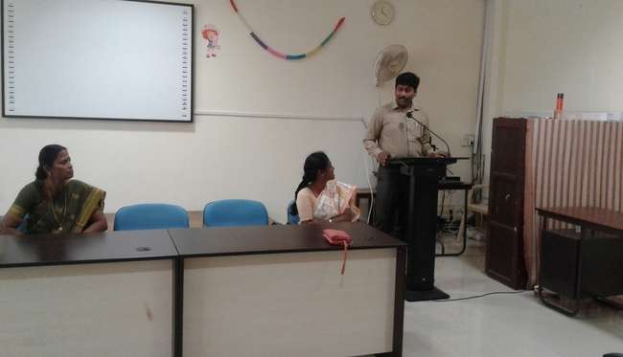
18.02.2017

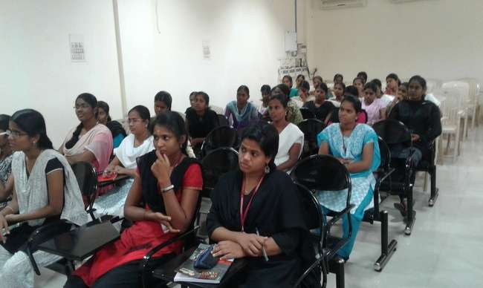

21.02.2017
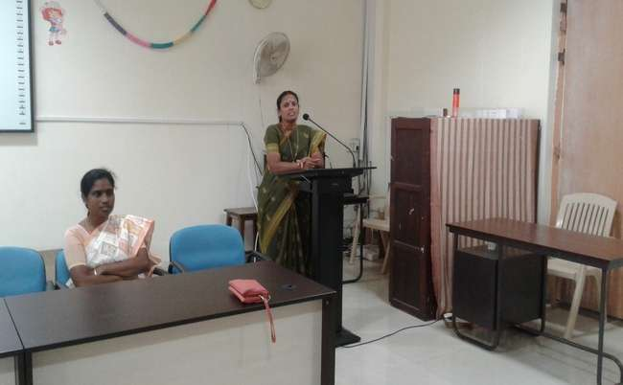

20.02.2017

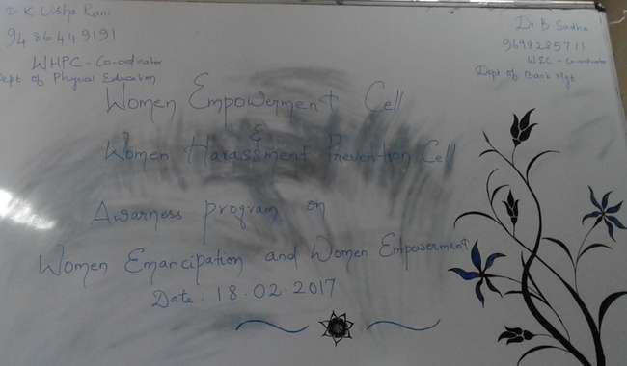
18.02.2017
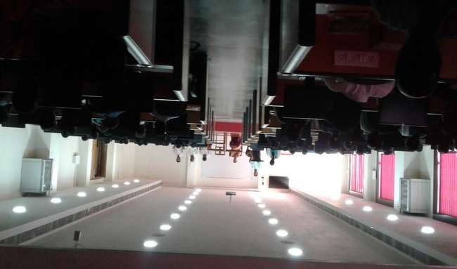

20.02.2017

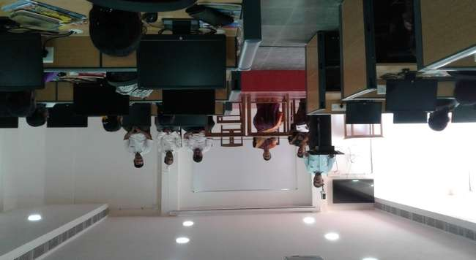

20.02.2017
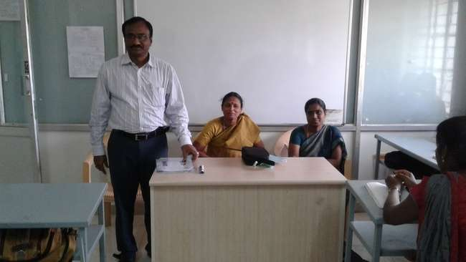

21.02.2017

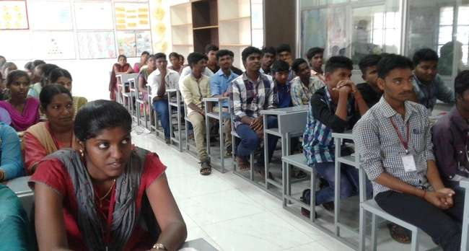

21.02.2017
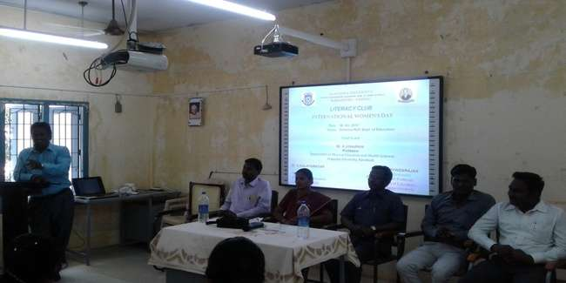

20.02.2017

s

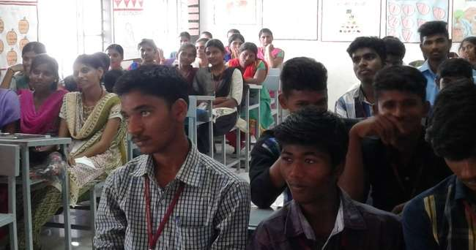
21.02.2017
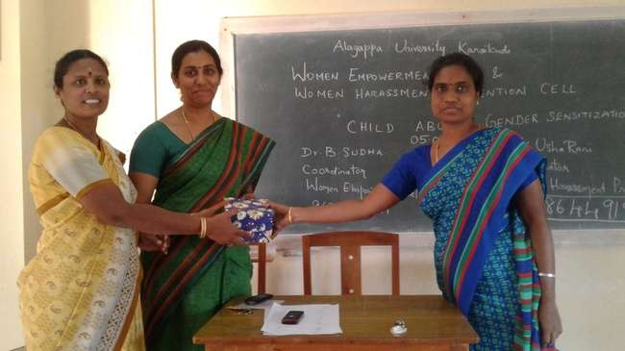

06.01.2017

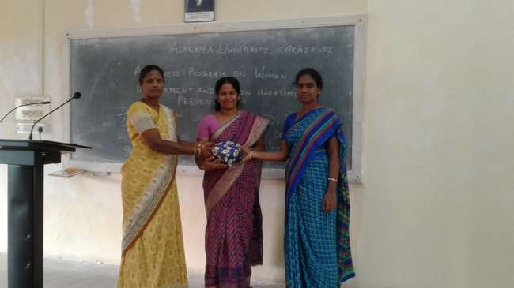

06.01.2017
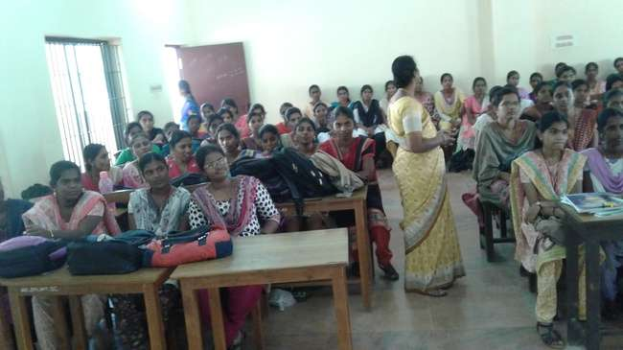

06.01.2017

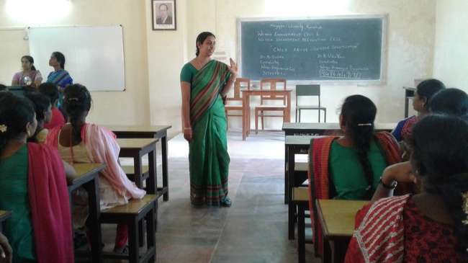

05.01.2017
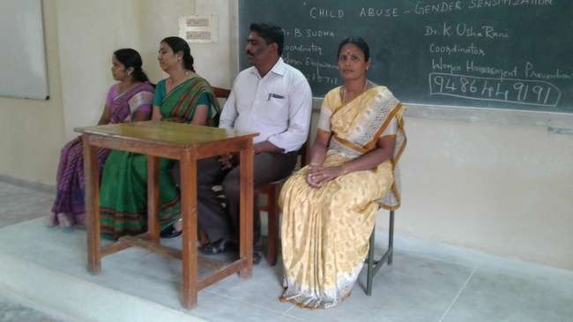

05.01.2017

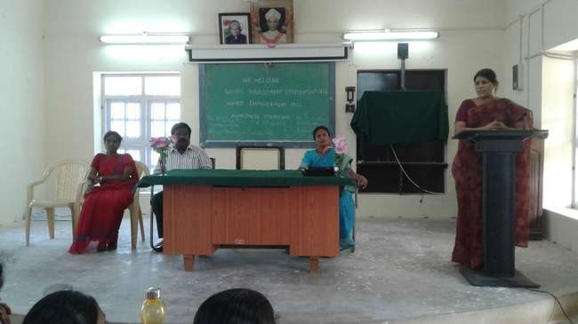

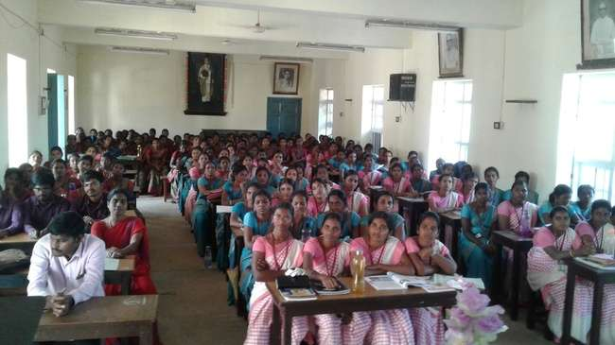

03.01.2017

