Women Empowerment Cell
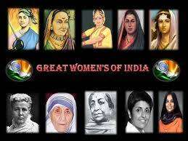 | 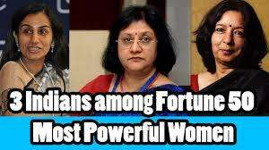 | 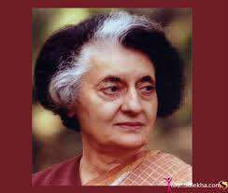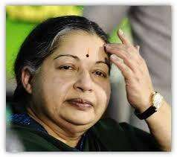
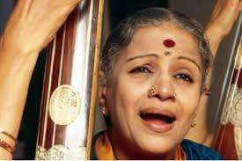 | 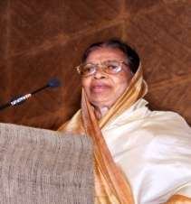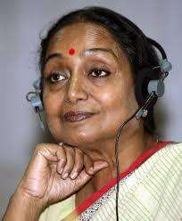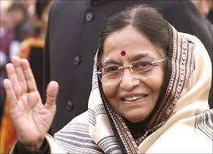 | 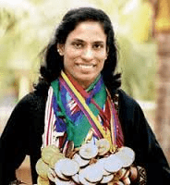

WOMEN EMPOWERMENT QUOTES
There is no chance of the welfare of the world unless the condition of women is improved. It is not possible for a bird to fly on one wing. – Swami Vivekanandha
To call woman the weaker sex is libel; it is man’s injustice to woman. If by strength is meant moral power, then woman is immeasurably man’s superior – Mahatma Gandhi.
There is considerable evidence that women’s education and literacy tend to reduce the mortality rate of children – Amartya Sen

ALAGAPPA UNIVERSITY WOMEN EMPOWERMENT CELL
Women empowerment refers to creation of an environment for improving the social and economic well being of women. According to the provisions of the Constitution of India, it is a legal point to grant equality to women in the society in all spheres just like male. It is thus the duty and mandate of every organisation to maintain conducive environment for female students and staff members to work with dignity and to share their problems. As ¾ th of the students of the Alagappa University. The cell strives to create awareness among women about their rights and privileges.

Aim and Purpose | Enabling women to realize their potential and power in socio economic and political spheres of life which results not only in women empowerment but also in the holistic development of the nation
 | Deliberating ways and means of women empowerment
 | Advocating the promotion of gender equality in the society

Name | Designation & Dept./Division/College. | Status
Dr.B.Sudha | Associate Professor, Department of Bank Management | Coordinator
Dr.M.Parimala Fathima | Assistant Professor, AUCE, Member | Member
Dr.S.Amutha | Assistant Professor, Department of Mathematics | Member
Ms.B.Jayagowri | Student, II M.Sc (CS) | Member
Ms.B.Nagajothi | Student, II MBA (B&I) | Member

Activities | Women Empowerment through Education
 | Women Empowerment by encountering challenges
 | Women Empowerment through Entrepreneurship
 | Women Empowerment through Political participation
 | Sensitizing the society on the need for Women Empowerment

Activities Carried out

Year | Description of Activity | Date | Participants/  Beneficiaries
2012 | Women Empowerment Celebrations  (Remembering the great women contribution of Dr.Muthulakshmi Reddy & Inspiring the budding women leaders) | 30th October 2012 | Gross Root Women, University Women Staff, University Students
2013 | International Women’s Day Celebration | 27th March 2013 | Gross Root Women, University Women Staff, University Students
2014 | Food Festive – Women EDP Trainees | 8th March 2014 | Women EDP Trainees ( EDP under the HRD Scheme of Ministry of Food Processing Industries)
2014 | Culture & Art Festive | 10th March 2014 | University Women Staff
2014 | Talent event for Gross root women | 11th March 2014 | Gross root women
2014 | Poster presentation & Street Play | 12th March 2014 | University Department Students
2014 | International Women’s Day Celebration | 14th March 2014 | Gross Root Women, University Women Staff, University Students
2015 | Girl Child Festive - Child Rights Campaign | 5thMarch 2015 | School Students
2015 | Art and Cultural Fest | 6th March 2015 | University Women Staff
2015 | Street Play & Poster Staging | 7 th March 2015 | University Department Students
2015 | Talent Fest | 8th March 2015 | Gross Root Women
2015 | Gender Sensitization | 9 th March 2015 | University Department Students
2015 | Commemoration of the International Women’s Day - 2015 | 10thMarch 2015 | Gross Root Women, University Women Staff, University Students
2015 | National Seminar on Safety and Security of Women and Girls Public Spaces: Planning and Designing Mechanism | 4th & 5th December 2015 | Gross Root Women, faculties of University Departments and Affiliated Colleges, women Empowerment Cell coordinators from Affiliated Colleges, University Students
2016 | Unite to End Violence against Women | 20.12.2016 | II MBA (B&I)
2016 | Women Harassment Prevention – A step towards Women Empowerment | 21.12.2016 | II MBA (B&I), M.PEd  B.PEd, Diploma Nursing  II M.Com (University Department Students)
2017 | Gender sensitive issues and women empowerment | 03.01.2017 | B.Ed (University Department Students)
2017 | Child Abuse Prevention and Intervention | 05.01.2017 | I M.sc (Mat), II M.sc (Mat) (University Department Students)
2017 | Women Emancipation and Empowerment | 18.02.2017 | I M.sc (Phy), II M.sc (Phy) (University Department Students)
2017 | Women Emancipation and Empowerment | 20.02.2017 | I M.sc (CS), II M.sc (CS) (University Department Students)
2017 | Women Economic Empowerment and Harassment Prevention | 21.02.2017 | I B.Voc, II B.Voc (University Department Students)

Future Activities to be carried out

Year | Description of Activity | Tentative Date | Budget | Participants/  Beneficiaries
2017 | Capacity Building Programme on Women Leadership | July, 2017 | 10,000 | Faculties of University Departments and Affiliated Colleges
2017 | Orientation Programme on Constitutional Provisions | August, 2017 | 5,000 | University Department Girl Students
2017 | Awareness Programme On Safety And Security Mechanism For Girls | September, 2017 | 5,000 | University Department Girl Students
2017 | Entrepreneurship Development Programme | October, 2017 | 5,000 | University Department Girl Students

PHOTO GALLERY Women Harassment Prevention – A step towards Women Empowerment
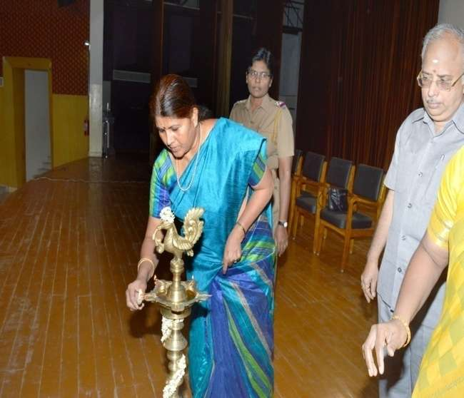  Lighting of Lamp | 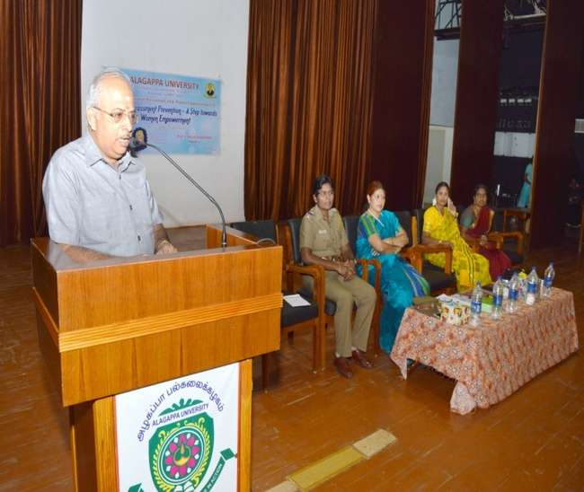  Registrar Prof. V.Balachandran addressing the audience
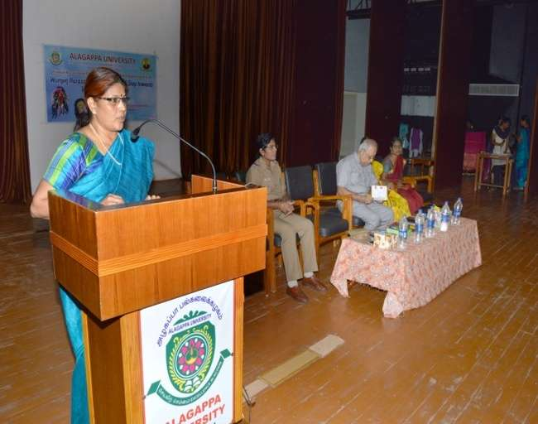  Prof.K.Manimegalai, Dean of Arts, delivered thematic address | 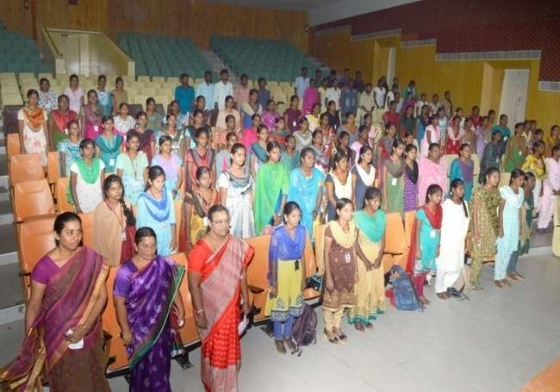  Participants: Students, Faculty Members and Non teaching staff
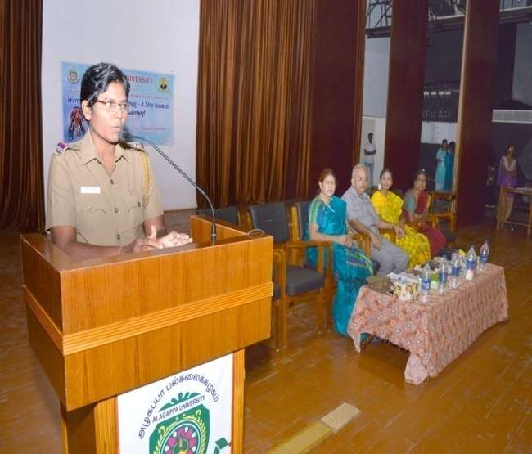  Sub-Inspector Mrs.S.Geethalakshmi, delivered special address and interact with the students | 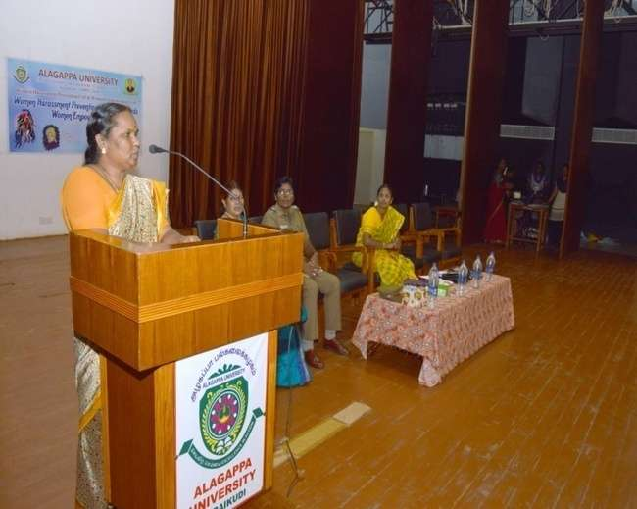  Senior Advocate Mrs.R.Senthamilselvi, addressed the participants
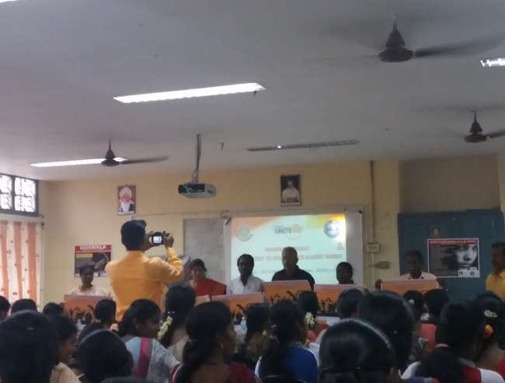  Dr.V.Balachandran, Registrar, release Unite to end violence against women poster in the awareness program, “Raise Money to end violence against women”. 20.12.2016 | 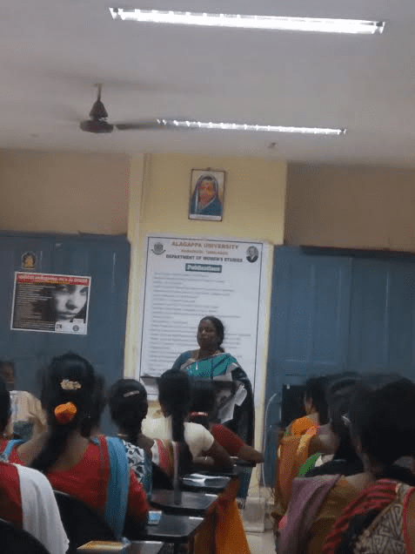  Mrs.C.Umayal, Social Welfare Officer, Sivagangai, addressed the participants
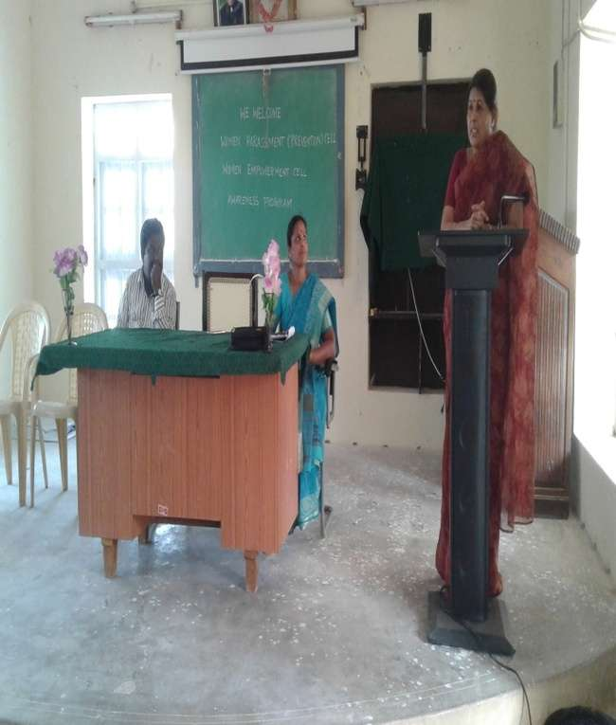  Dr.V.Balu, Principal, College of Education, preside the program, “Gender sensitive issues and women empowerment” 03.01.2017. | 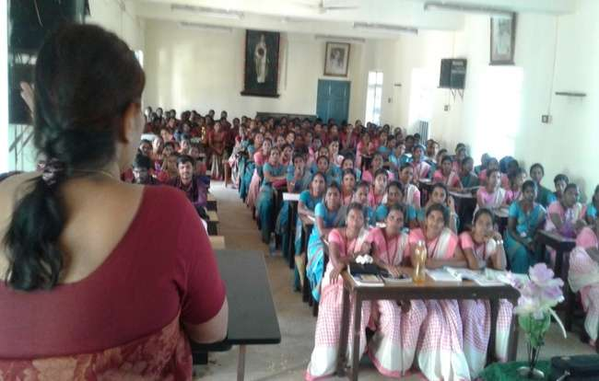  Dr.K.Manimekalai, Dean of Arts, empowering the B.Ed students  Participants: All students in the College of education
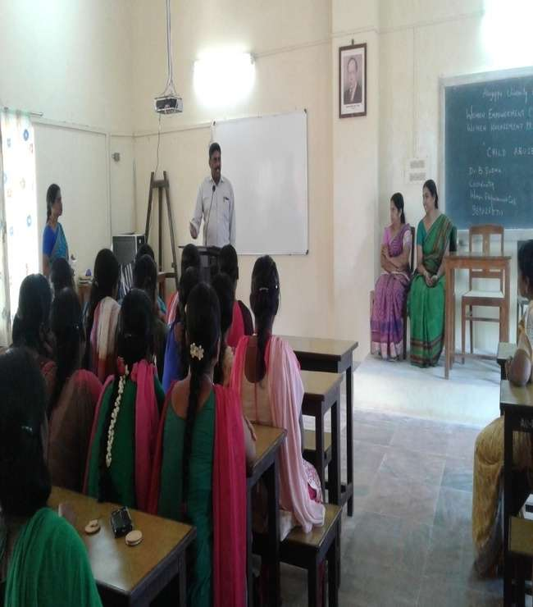  Dr.N.Anbazhagan, Professor and Head, Dept of Mathematics delivered presidential address in the awareness program, “Chil abuse prevention and intervention”, 5.1.2017 | 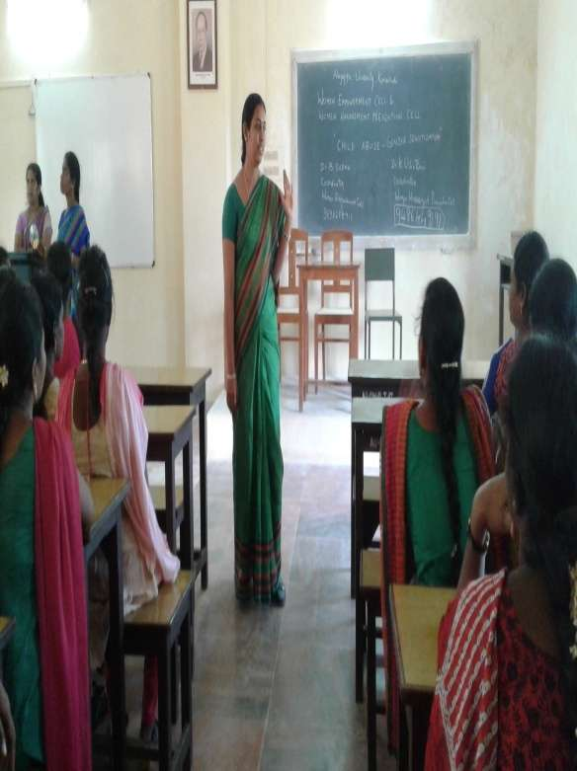  Dr.N.K.Bhuvaneshwari, Dr. S.Poul Punitha, Assistant Professor, Department of Women studies, addressing the Participants  Participants: All students in the Department of Mathematics.
D Dr.G.Ravi, Professor and Head, Dept of Physics, delivered presidential address in the awareness program Women Emancipation and Empowerment,18.02.2017  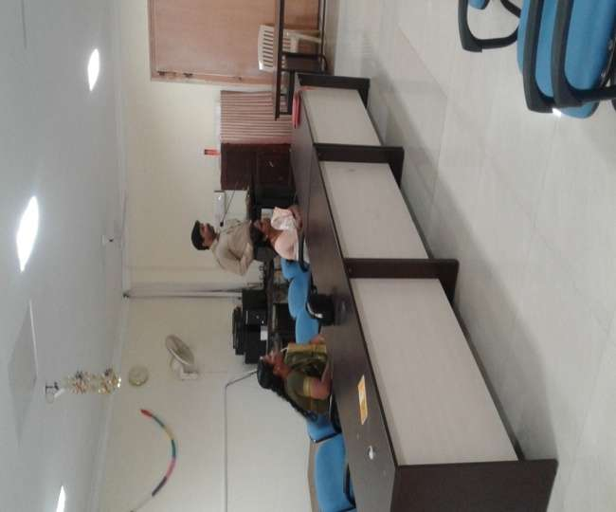 | Participants of the program (Dept of Physics students)  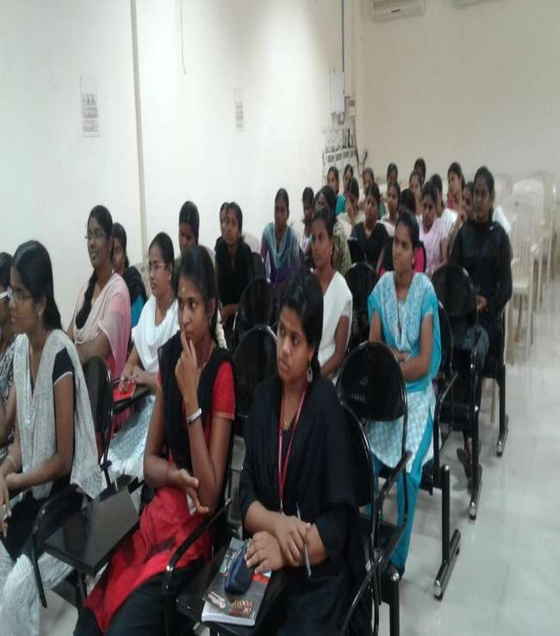
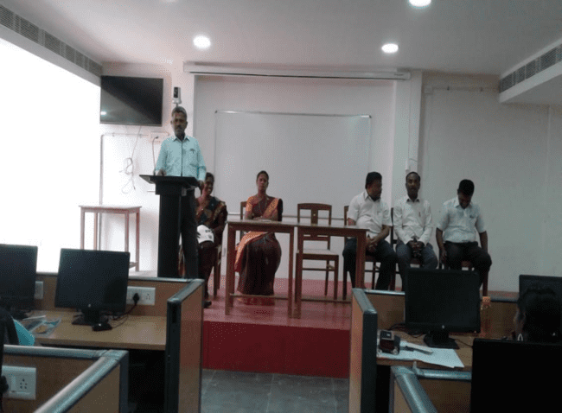  DrV.Palanisamy, Professor and Head, Dept of Computer Application, delivered presidential address in the awareness program Women Emancipation and Empowerment, 20.02.2017 | 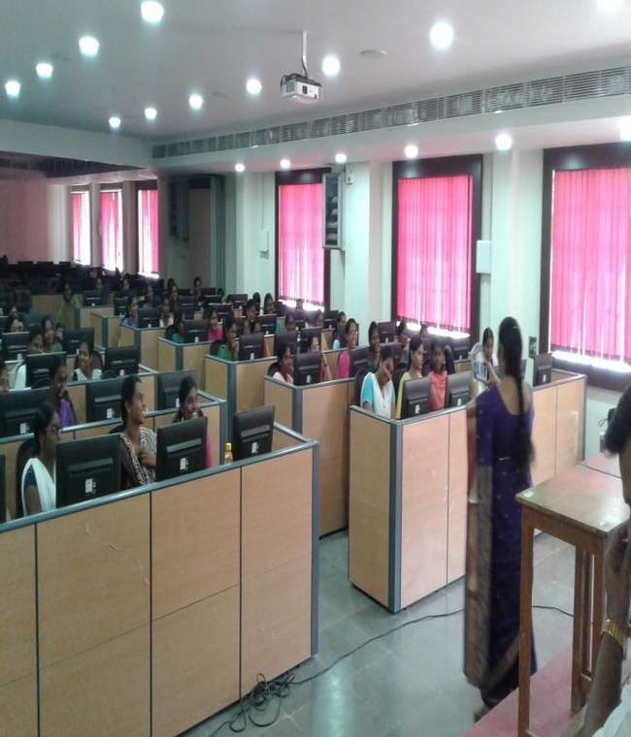  Participants of the program (Dept. of Computer Application students)
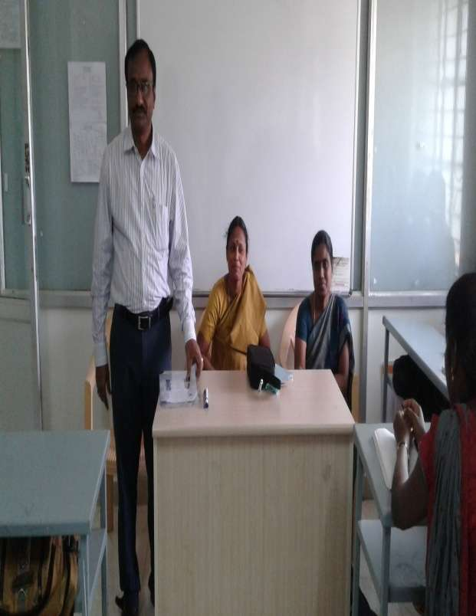  DrB.Dharmalingam, Professor and Head, Alagappa Institute of skill development, delivered presidential address in the awareness program Women Economic Empowerment, 21.02.,2017 | 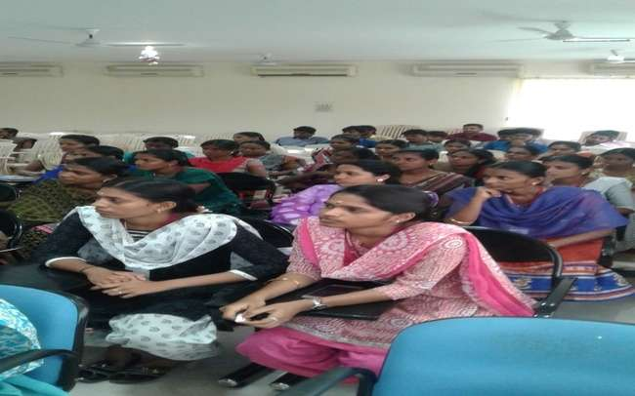  Participants of the program

